RAILWAY RESERVATION SYSTEM

DFD

* **Level 0 DFD:**

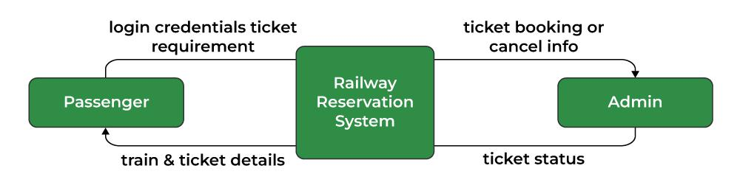

* **Level 1 DFD:**

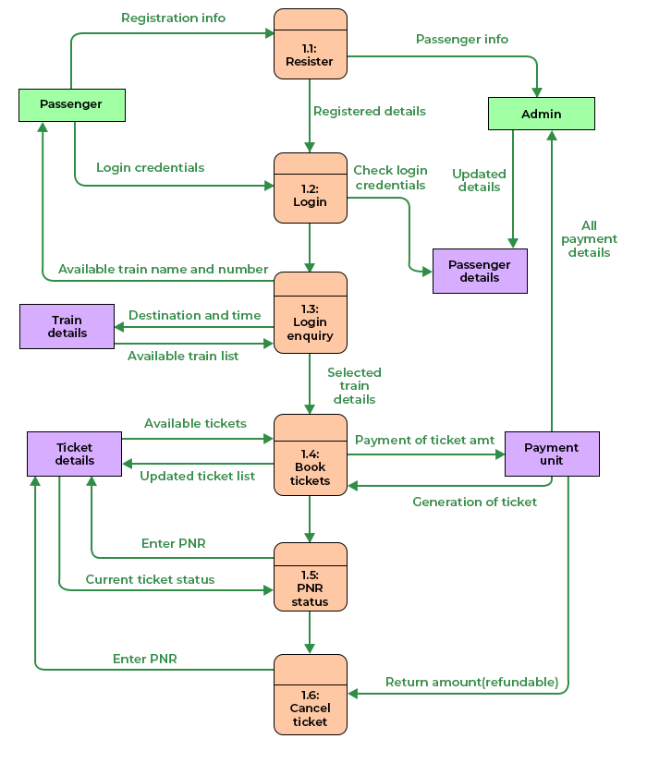

CLASS DIAGRAM

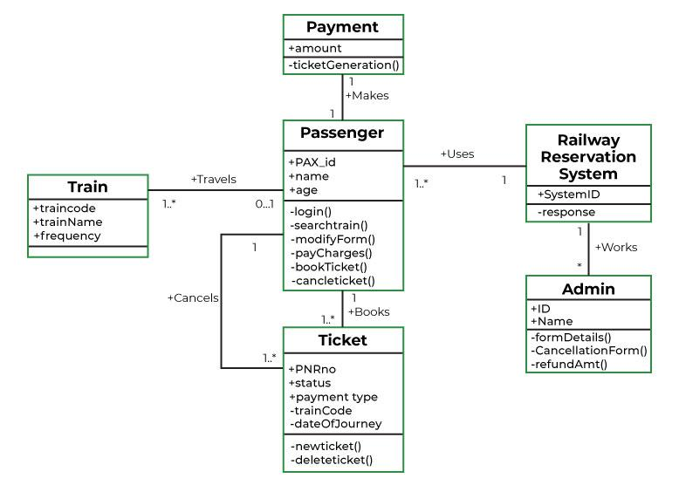

SEQUENCE DIAGRAM

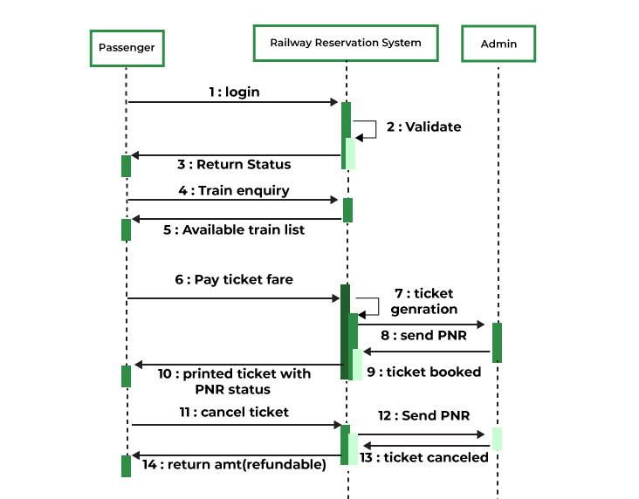

ACTIVITY DIAGRAM

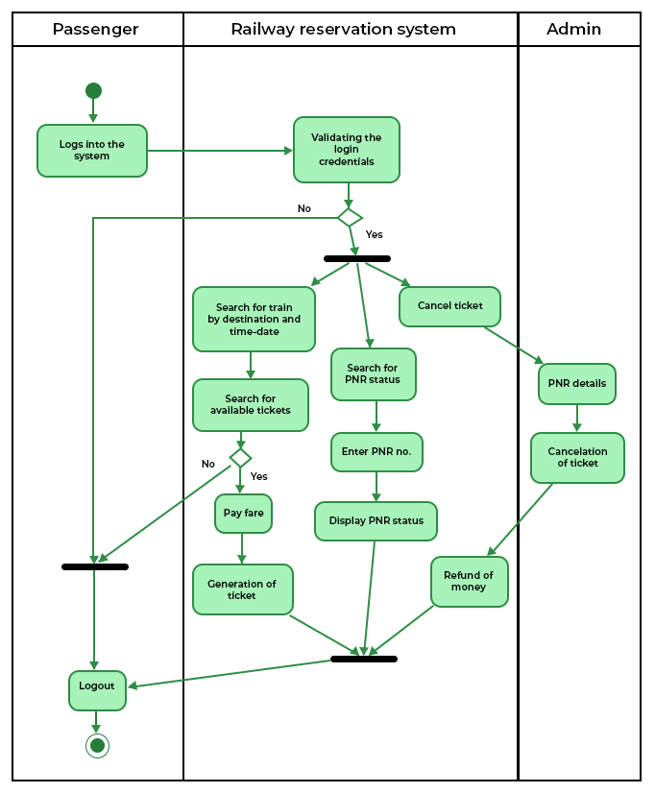

USE CASE

